**bioMorph Contract**

The following contract is presented to you, our client, by TriHelix Solutions, and it stands as a document of acknowledgement from the serviced party that our company has successfully achieved your expectation of the desired application: bioMorph.

Client’s Full Name: ___________________________  
Date: ________________________________________

By signing below, you acknowledge that TriHelix Solutions has completed bioMorph in alignment with your specified needs. You also indicate that you are satisfied with the outcome of the guaranteed main components of the application that were outlined in the preliminary report you received on Monday, April 27th, 2015.

We hope to have fulfilled your expectations, as our team has worked very hard to bring you the finished application.

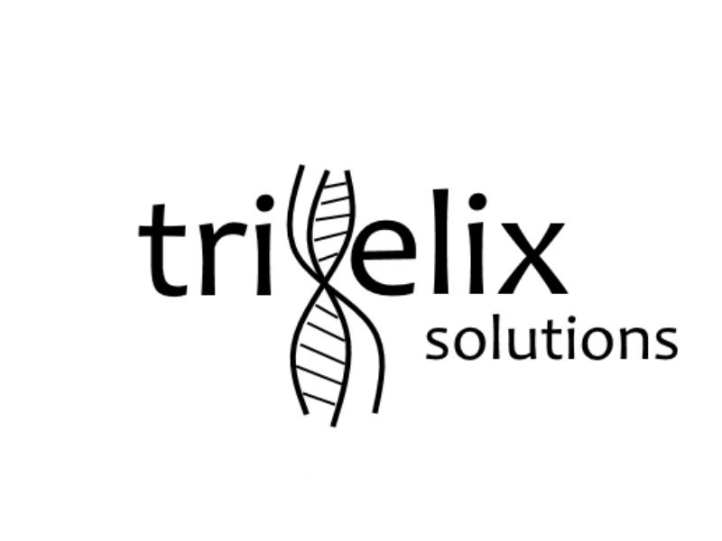Client’s Signature: ____________________________

**TriHelix Solutions**  
Member Signatures: